Eligibility: for PSSLAI members

FAQs:

KonsultaMD Service-related questions –

- What is KonsultaMD?
KonsultaMD is a telehealth service that provides 24/7 access to licensed doctorsto address your general and mental health concerns, NO appointment needed. You can consult a doctor via chat, voice or video call from the comfort of your home.

- What are the key features of KonsultaMD?
- 24/7 Telemedicine Consults. Talk to a licensed general physician anytime via chat, voice or video call, no appointment needed. Just download the KonsultaMD app on Google Play, AppStore, or AppGallery. Or call the hotline.
- Primary Medical Advice. Get primary medical advice on basic healthcare, primary conditions such as cough, fever, cold, allergies, and permissible medication over the phone.
- General Health Information and/or Diagnostics Interpretation. KonsultaMD doctors provide information on any health-related inquiry, which includes the interpretation of laboratory results and diagnostic examinations.
- Access to e-Medical Documents. KonsultaMD doctors may provide important medical documents such as e-prescription, e-laboratory request, and e-medical certificate upon the doctor’s discretion. These are accessible through SMS or the KonsultaMD app.
- Immediate Access to Doctors. Consult a doctor with a guaranteed wait time of 5 minutes or get your money back when you use a Fast Pass.
- Mental Health Support. Receive mental health first-aid support through KonsultaMD’s Mental Health Counsellor, trained to take care of your mental well-being.
- What medical information will I receive?
- Medical information for primary conditions (defined as cough, fever, cold, flu, pink eye/sore eyes, sinus infections, urinary tract infections, bronchitis, rashes, allergies, asthma) and permissible medication over the phone.
- Reading of, and information on lab and diagnostic results, permissible medication (over the counter medication)

KonsultaMD Christmas Bundles offer

- What is the KonsultaMD Christmas Bundle offertoPSSLAImembers?
PSSLAImembers can avail any of the KonsultaMD Christmas Bundle offer listed below;

 | Christmas Bundles
1 | Gift of HEALTH Bundle #1 | Personal Plan (6 months) + Vitamin C w/ Zinc (10 pcs)
2 | Gift of CLARITY Bundle | Mental Health Video + Fish Oil (10 pcs)
3 | Gift of BEAUTY Bundle | KonsultaMD FAST Pass + Collagen (10 pcs)
4 | Gift of HEALTH Bundle #2 | Konsulta CHAT GP + Vitamin C w/ Zinc (10 pcs)

- What is included in Gift of Health (bundle #1)
Gift of Health Basket #5 includes the KonsultaMD Personal Plan (6-months subscription)
  - 6-months membership for 1 primary member
  - With UNLIMITED voice consult
  - 1 FREEE video consult per month
  - Access to e-Prescription, e-Laboratory Request, e-Medical Certificate
  - Access to Partner Benefits. Check https://konsulta.md/partners-promos for more details.
  - 10 pcs of Vitamin C w/Zinc (claim at participating Generika Drugstores)

Note: KonsultaMD partners and its offers are subject to change without prior notice.

- What is included in Gift of Clarity
Gift of Clarity Basket #2 includes the KonsultaMD access to Mental Health Video Consult
  - Talk to a Mental Health Counsellor through video call (1 time access)
  - Available 24/7, NO appointment needed
  - Access to e-Prescription, e-Laboratory Request, e-Medical Certificate
  - Access to Partner Benefits. Check https://konsulta.md/partners-promos for more details.
  - 10 pcs of Fish Oil supplement (claim at participating Generika Drugstores)

Note: KonsultaMD partners and its offers are subject to change without prior notice.

- What is included in Gift of Beauty
Gift of Beauty Basket #10 includes the KonsultaMD FAST PASS access
  - Fastest way to consult a doctor via FAST PASS (1 time Video consult)
  - Guaranteed wait time of 5 minutes or less
  - Access to e-Prescription, e-Laboratory Request, e-Medical Certificate
  - Access to Partner Benefits. Check https://konsulta.md/partners-promos for more details.
  - 10 pcs of Collagen supplements (claim at participating Generika Drugstores)

Note: KonsultaMD partners and its offers are subject to change without prior notice.

- What is included in Gift of Health (bundle #2)
Gift of Health Basket #3 includes the KonsultaChat with GP
  - Chat consult with a General Physician (1 time access)
  - Available 24/7, NO appointment needed
  - Access to e-Prescription, e-Laboratory Request, e-Medical Certificate
  - Access to Partner Benefits. Check https://konsulta.md/partners-promos for more details.
  - 10 pcs of Vitamin C w/Zinc (claim at participating Generika Drugstores)

Note: KonsultaMD partners and its offers are subject to change without prior notice.

- When does the KonsultaMDsubscription start for PSSLAI member?
- PSSLAI member should download the KonsultaMD mobile app, register their mobile number and create a subscriber profile within the app
- The actual KonsultaMD subscription starts as soon as the KonsultaMD voucher code is successfully inputted into the KonsultaMD mobile app, and the subscriber is notified of the subscription status*.
*Upon input of the voucher code in the ‘ENTER VOUCHER CODE’ field, subscriber will receive a notification of successful activation. The subscribed service is already active, and subscriber can proceed with doctor consultation via hotline, video consult, chat, FAST PASS or Mental Health support.

- How do I consult with a KonsultaMD doctor?
PSSLAI member can consult with KonsultaMD doctors as soon as the subscription has been activated. PSSLAI member can use the KonsultaMD app for an enhanced teleconsulting experience. Similarly, consulting with a doctorcan be done by calling the KonsultaMD hotline.
- For Voice Consults, you may call KonsultaMD (02) 7798 8000 (Globe/TM) or 0919 056 0702 (Smart)
- For Video Consults, follow the steps below:
- Tap the TALK TO A DOCTOR page on the app.
- Click VIDEO CALL.
- Input the reason for your consultation and attach supporting files if any, then click ENTER WAITING ROOM.
- Consult a doctor.
Note: If performing a video consult on the app, data charges may apply if you are not connected to a WiFi network.
- How many times can I consult in a week or a month? Is this unlimited consultation?
For PERSONAL and ANNUAL subscription, you can call the KonsultaMD hotline (02-7798 8000) as many times as you need within the duration of your subscription. There is no limit to the number of call consultations within your subscription period. For video access, your subscription plan includes video consults per month (the number of FREE video consults included varies depending on the type of plan availed).

- When does my subscription end?
Your KonsultaMD plan/service will end 6 months (for PERSONAL PLAN) or 12 months (for FAMILY PLAN) after the activation of your subscription. Please check the subscription validity date shown in your account information.

- How do I add my dependents on my FAMILY ANNUAL plan?
You may create a separate profile for your dependents by following these steps:
- Log in using the primary account’s mobile number.
- Click VIEW MY PROFILE on the dashboard.
- Select the ADD DEPENDENT option.
- Fill out the necessary information, then click SAVE PROFILE to finish.
- How can my dependent do a video consult using the app?
Dependents can do video consults in just a few steps:
- Log in using the primary account’s mobile number.
- Select GO TO MY PROFILE while logged on to the primary holder’s account.
- Swipe to the dependent profile you want to use.
- Click TALK TO A DOCTOR, or click VIDEO CALL
- Input reason for calling a doctor.
- Your dependent can now start consulting a doctor.
- I want to opt-out / cancel my KonsultaMD Health Plan. How do I cancel it?
You can cancel your health plan through the app. Go to the Subscription tab of the app then tap 'CLICK HERE' to cancel your health plan.

You may also call the KonsultaMD hotlineat 02-7798 8000from 8AM to 11PM and speak to a Wellness Representative for assistance, if needed.

- Who can assist me if I have other questions about KonsultaMD?
You may contact our Wellness Representatives either through our hotline, email or Facebook page.
  - KonsultaMD hotline 02-7798 8000. Press "0" for Customer Service to talk to a Wellness representative
  - Facebook page - https://www.facebook.com/konsultamd
  - Email – wellness@globaltelehealth.com.ph

KonsultaMD Service-related questions – General Information

- Who is eligible to own a KonsultaMD health plan?
Anyone who is eighteen (18) years old or above.

- If I change my mobile number, what will happen to my KonsultaMD subscription?
We encourage you to contact our Wellness Representatives either through the hotline, email or Facebook page to update your mobile number so that you won’t experience any service disruption.

- Can I do follow up consultation/check-up in KonsultaMD?
Yes, you can. Follow up consultation is highly encouraged especially if it’s included in the doctors’ instructions.

- Are there other call charges when I call the hotline?
See table below for the applicable call charges:

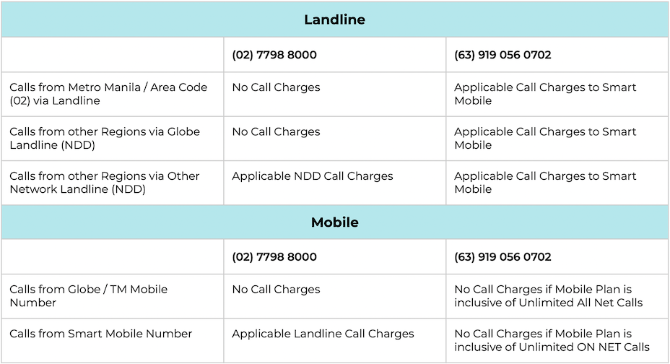
Notes:
- NDD - National Direct Dialing
- Calls from outside the Philippines are charged International Direct Dialing (IDD) Rates

Other concerns -

- What is the difference between KonsultaMD Health Plans and KonsultaMD Pay per Consult products?
KonsultaMD Health Plans are subscription-based and are paid per year depending on the kind of plan you purchase.
Pay per Consult products are paid on a per consult basis. You do not need to be a KonsultaMD Health Plan member in order to avail of these products.

- How can I be assured that I am talking to a licensed doctor?
KonsultaMD screens all its applicant doctors and ensures that these doctors have a PRC license prior to hiring. KonsultaMD also conducts rigorous trainings for its licensed doctors for their continuing medical education (CME) to maintain their competence in providing quality healthcare for you.
Note: CME is the process by which health professionals engage in activities or webinars to support their continuing professional development.

- I already called and consulted a doctor. Can I call again and ask for a second opinion from another doctor?
Definitely! Voice consults are unlimited so you can call as many times as you want. While there is no guarantee that your call will be routed to another doctor right away, you can always try to call again another time and get a second opinion from another KonsultaMD doctor.

- Is it possible to get information on the nearest specialist of doctor in a clinic/hospital?
Yes. Please advise our doctors of your location and they will do their best to provide you with information of a nearby clinic/hospital.

- I liked how the last doctor I talked to handled my concern. Can I request for the same doctor the next time I call?
Due to the volume of calls, there is no guarantee that your call will be routed to the same doctor. Rest assured that all doctors of KonsultaMD are professionally trained to take your call and will have access to your medical history on the app.

- Are all consultations (chat, voice, or video) offered by KonsultaMD secure and confidential?
All consultations are 100% secure and confidential. By law and ethics, doctors are bound to maintain the confidentiality of each session. There may be limits such as if the patient is in danger or the people around the patient may be in danger.

We highly prioritize doctor-patient confidentiality and that’s why we would also like to remind patients that as per the National Privacy Commission, taking screenshots and disclosing private conversations involving personal data, such as names or addresses, or other sensitive materials, without the consent of the involved parties is not allowed.

- How sure am I that I will get an accurate assessment if the doctor cannot see me (in the hotline)?
KonsultaMD doctors are trained to provide primary medical advice on basic healthcare and permissible medication over the phone. Please note that they only provide initial assessment, which should not replace physical assessment. Rest assured that the doctor who will handle your call will inform you if there is a need to have face-to-face consultation with a doctor.

- Will the doctor still be able to interpret e-Laboratory results if I cannot upload through the app? (e.g., calling through the hotline)?
Yes, you would just need to read your results to the doctor during the consultation.

- If I require prescription medication that requires S2 License, will KonsultaMD be able to prescribe?
No, KonsultaMD doctors cannot prescribe medication that requires S2 license since this type of medication warrants a face-to-face consultation and/or requires diagnostic examinations prior to prescribing.

- Do you issue Medical Certificates for Fit to Work?
Yes, KonsultaMD may issue medical certificates for fit to work at the discretion of the attending physician. The issuance of the medical certificate will depend on the information gathered by the doctor from the consultation and if it follows KonsultaMD’s guidelines.

Ver. 11232022

